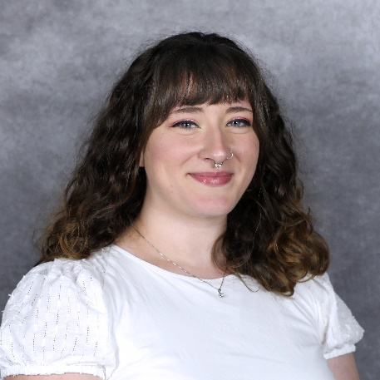
From RCC Student to Employee
Paris Nelson earned an associate in arts and sciences degree from RCC in 2019. “While I was a student here at RCC, it was some of the best times,” said Nelson. She took a mixture of online and in-person classes, and especially enjoyed coming to campus for classes because the student lounge was always filled with people either playing pool or ping pong or playing games like Dungeons and Dragons. Her favorite classes were in Biology. “The atmosphere was always welcoming and exciting.”
After graduating from RCC, Paris started taking classes at VCU and got a job in RCC’s testing center. She then transferred to working for the Student Help Desk as an Instructional Support Technologist. "I helped students get logged into their accounts to give them access to Canvas and their accounts is a vital step in completing course work,” she said. “I like helping the students and talking to them about what classes to take, what can transfer, and how to navigate the systems they need to use.”
Paris continues to learn and help students at RCC since she sees the value of going to a community college as the first steppingstone to advance one’s education. She is now an Admissions and Records Technician, at the same time, just started her graduate degree at the University of Idaho studying Human Factor Psychology. In the Admissions and Records department, her favorite thing to do is help students who need to know what their first step is. Whether it's helping them apply to RCC or guiding them on what steps to take after applying. She remembers how intimidating it once was starting college, and no matter the age, those nerves are the same for all people.
“I like to help the next generation of students realize the value of learning new skills, whether it be for a certificate program, workforce, or getting their AA to transfer,” she said.

