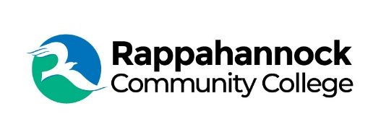

Rappahannock Community College

Michele Inderrieden

Media Services Manager

[minderrieden@rappahannock.edu](mailto:minderrieden@rappahannock.edu)

(804)333-6824

April 29, 2024

**RCC Students Inducted into Honor Society**

Rappahannock Community College (RCC) inducted 28 students into Phi Theta Kappa (PTK), Alpha Lambda Omicron Chapter, Honor Society in a recent ceremony held at Essex High School. PTK is an international honor society recognizing full-time, two-year college students who maintain a GPA of 3.5 or higher. Members receive opportunities for scholarships, develop leadership skills, and participate in volunteer activities.

RCC President Dr. Shannon Kennedy welcomed the students and their guests. “What an honor it is to be part of the premier community college honor society in the country,” said Kennedy. “You should be proud of your grades, your heart of service, and your dedication to academics and community.”

Guest speaker, Therese Johnson, retired math professor and former PTK faculty advisor, shared her educational journey. “I didn’t know what I wanted to be or study when I was in college and that’s ok. But I was a hard worker and I liked math because there is always a correct answer,” said Johnson. “Now is the time to try things and discover what you like, what you have a passion for.”

The new inductees are: Elizabeth Ashton, Paris Bacon, Catherine Billips, Cassy Blevins, Glenda Brown-Snowden, Evan Cagnina, Jacob Dunn, Aiden Eanes, Alexis Franklin, Chloe Garner, Daisy Harris, Sean Headley, Alayna Holcomb, Damani Jackson, Logan Johnson, Pamela Johnson, Abigail Lazar, Amaiya Lee, Cassy Leigh, Patricia Luna-Wright, Savannah Morrow, Lucas Osborne, Alec William Stokes Pesola, Elizabeth Rector, Minajhadore Redd, Elexas Reynolds, Anthony Sinare, and Mercedes Stevens.

Three current PTK students were named to the PTK 2024 All-Virginia Academic Team. Savana Balderson, Nicholas Davis, and Liselle Morning were among the students recognized by Virginia Community College System (VCCS) Chancellor Dr. David Dore at a luncheon in Richmond.

“I’m just honored to be here. I still can’t believe it!” said Morning, an immigrant from Trinidad and Tobago. She is the first person in her family to attend college. The mother of four said, “I had moments when I wanted to give up, but my advisors kept pushing and encouraging me.” Morning is on track to graduate next spring and has plans to continue her studies to become a clinical psychologist.

PTK is the first honor society recognizing academic achievement of students at two-year degree colleges, and helps them grow as scholars and leaders. RCC’s faculty advisors leading the PTK chapter are English Professors Janet Little and Jennifer Newhouse.

###

Since 1970, Rappahannock Community College has been breaking down barriers to education in the Middle Peninsula and Northern Neck. Five degrees, 6 certificates, and 26 career and workforce studies programs are offered through RCC, in addition to nearly 40 guaranteed admissions agreements with colleges and universities across the state and region. For more information, visit rappahannock.edu.